Hulsebus Chiropractic Clinic
1010 Harlem Road • Machesney Park, IL 61115
815.654.1044

Patient Information
Name: ___________________________________________________________ (Age) ______ Gender: M F
Home Address: ____________________________________________________ Home Phone: ( ) ____________
City, State, Zip: ____________________________________________________ Work Phone: ( ) ____________
Email Address: ____________________________________________________ Cell Phone: ( ) ____________
Birth Date: ____/____ /_____ Social Security #: _____ -_____ -_______ Marital Status: S M D W
Occupation: _________________________________________ Employer Name: _______________________________
Spouse’s Name: ___________________________ Work Phone: ( ) _____________ Cell Phone: ( ) _______________
Spouse’s Employer: ________________________________________ Occupation: ___________________________________
How were you referred to this office? ______________________________ Have you seen a Chiropractor before? Yes / No

Purpose for This Visit *If your symptoms are the result of an auto accident or work-related injury, please see the front-desk.
Reason for this visit: ______________________________________________________________________________________
Describe: _______________________________________________________________________________________________
When did these symptoms begin? ____/____ /_____ How did your symptoms start? _______________________________
Are they getting worse? Yes / No Are they: Constant Intermittent Activity-related
Do they interfere with: Work Sleep Hobbies Daily Routine Pain Scale: _____ (0 being no pain-10 being worst pain)
Explain: _______________________________________________________________________________________________
What activities aggravate your symptoms? ___________________________________________________________________
Is there anything that relieves your symptoms? _______________________________________________________________
Have you experienced these symptoms before? Yes/ No
If yes, explain: __________________________________________________________________________________________
Have you been treated for this? Yes / No When were you last treated? ____/ ____ /____
Who did you see? _______________________________________________________________________________________
What treatment was performed? __________________________________________________________________________
How did you respond? ___________________________________________________________________________________

Health & Lifestyle
Do you exercise? Yes / No How often? _____ day(s) per week
What activities? Walking Running/Jogging Weight Training Cycling Yoga Pilates Swimming Other: __________
Do you smoke? Yes / No How much? / How often? ____________________________________________
Do you drink alcohol? Yes / No How much? / How often? ____________________________________________
Do you drink coffee? Yes / No How much? / How often? ____________________________________________
Do you take any supplements (i.e. vitamins, minerals, herbs) or Prescription Medications? Yes / No
If yes, please list: _______________________________________________________________________________________
_____________________________________________________________________________________________________
_____________________________________________________________________________________________________
Are you allergic to any Medications? Yes / No If yes, please list: _________________________________________________

Height: ________ Weight: ________ Blood Pressure: ____________
GENERAL SYMPTOMS CHART

Please use the following notations on the figures below to indicate the type and location
of your symptoms, as it relates to the purpose of your visit today.

A = ACHE
B = BURNING
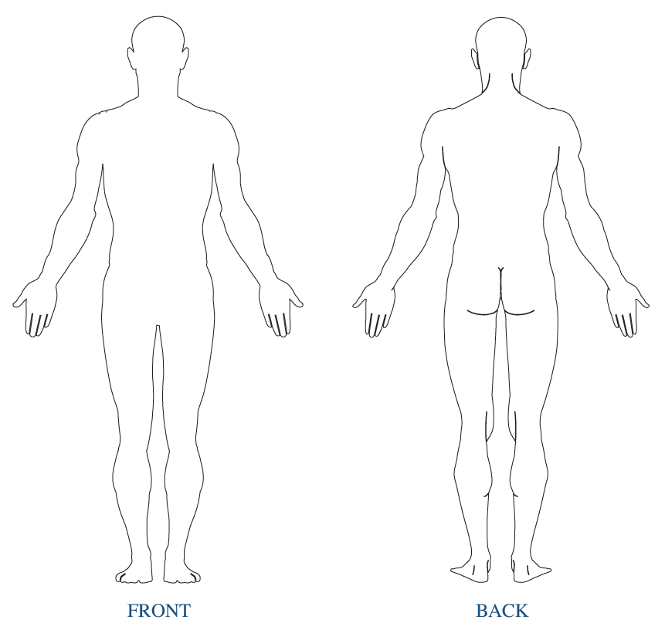
P = PINS & NEEDLES
G = STABBING
M = SPASMS
F = STIFFNESS
N = NUMBNESS
T = TINGLING

Left Right
Right Left

Health Conditions
Your spine is the foundation of health and core strength in your body. Shifts in the vertebrae or sections of the spine will spread ultimately causing weakness and distortion to ALL the areas of the spine. These distortions are reflected in abnormal posture. Research shows abnormal posture leads to chronic pain, disease and possibly a shortened life span. Please answer the following questions accurately so we may determine the full extent of your condition.

Please indicate (N) = Now, (P) = Past next to all conditions you’ve experienced or both if applicable.

CERVICAL SPINE (Neck)

____ Neck Pain ____ Coldness in hands ____ Hearing disturbances
____ Pain in shoulders/arms/hands ____ Headaches ____ Sinusitis
____ Numbness/tingling in arms/hands ____ Dizziness ____ Allergies/Hay fever
____ Weakness in grip ____ Visual disturbances ____ Thyroid conditions

THORACIC SPINE

____ Mid-Back Pain ____ Heart Palpitations ____ Recurrent Lung Infections/Bronchitis
____ Pain in Ribs/Chest ____ Heart Murmurs ____ Asthma/Wheezing
____ Heartburn ____ Heart Attacks/Angina ____ Shortness of Breath
____ Nausea ____ High Blood Pressure ____ Diabetes

LUMBAR SPINE (Low Back)

____ Low back pain ____ Numbness/tingling in legs/feet ____ Frequent/difficulty urinating
____ Pain in legs/feet ____Coldness in legs/feet ____ Constipation/ Diarrhea/ IBS
____ Pain in hips/knees/ankles ____ Muscle cramps in legs/feet ____ Menstrual irregularities/cramping

OTHER
Have you ever been hospitalized? Yes/ No
Please list any surgeries (include type of surgery and date it was performed): ___________________________________
__________________________________________________________________________________________________
__________________________________________________________________________________________________
__________________________________________________________________________________________________

Pregnancy Release
This is to certify that to the best of my knowledge I am not pregnant and the above doctor and his associates have my permission to perform an x-ray evaluation. CIRCLE ONE: Pregnant / Not Pregnant

Emergency Contact

Name: _____________________________________ Relationship: _________________________ Phone# _____________________

